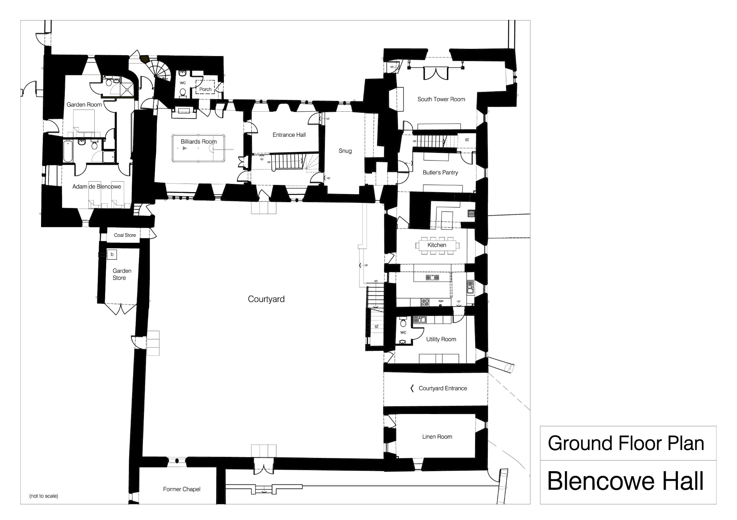
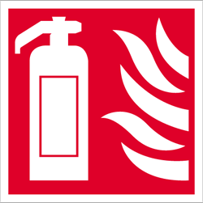



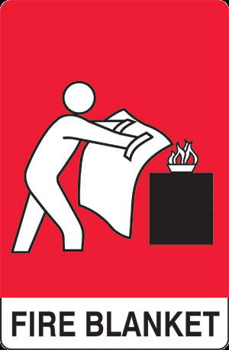
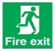
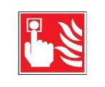

Fire Plan

Ground Floor Plan

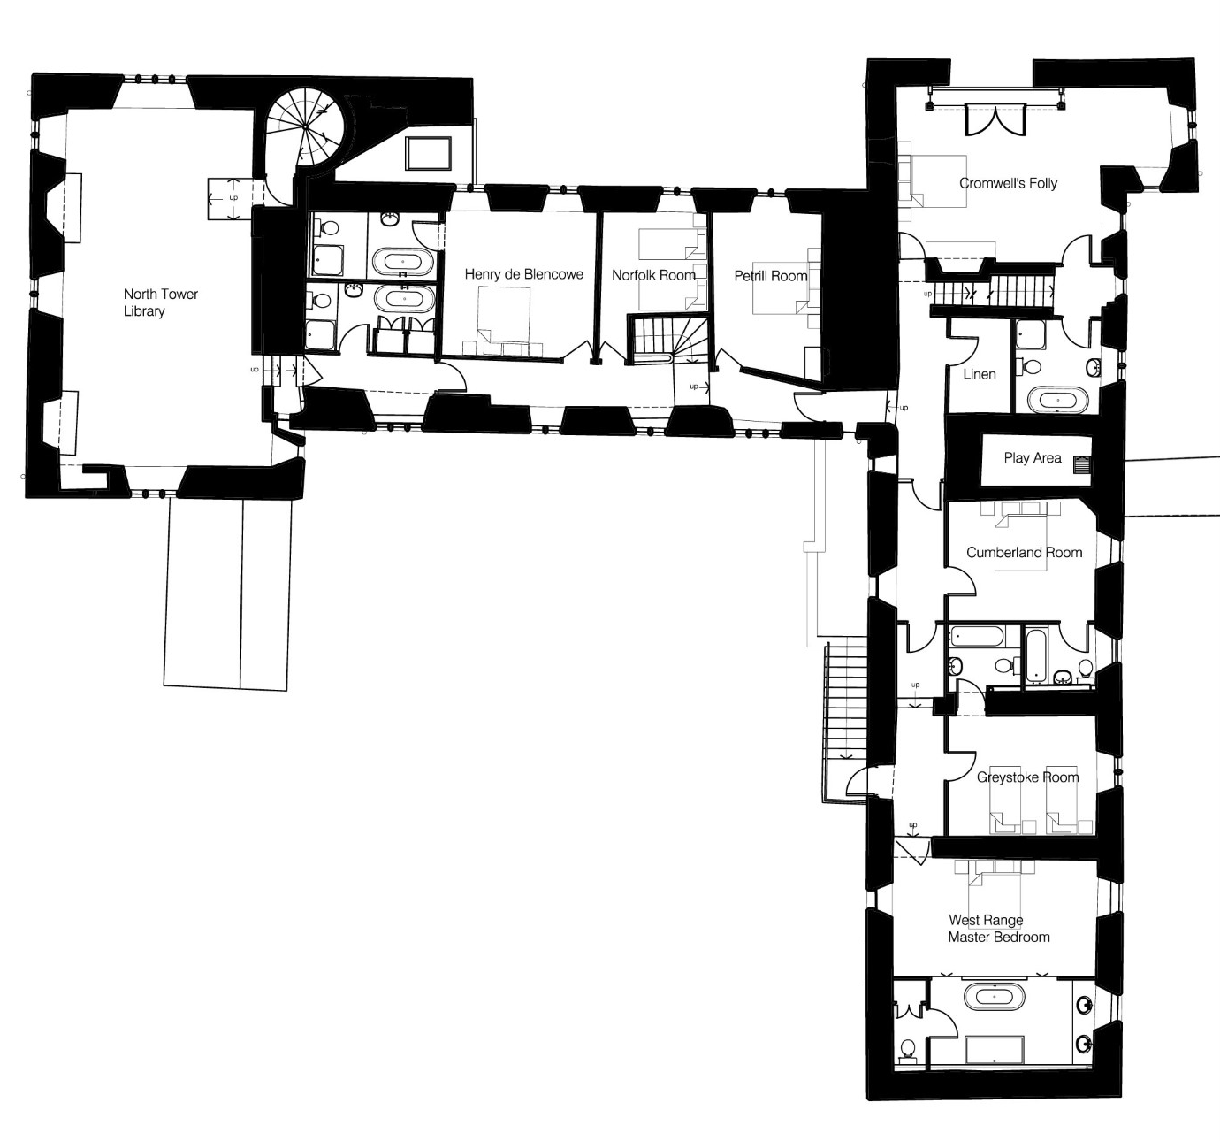

Fire Plan
First Floor

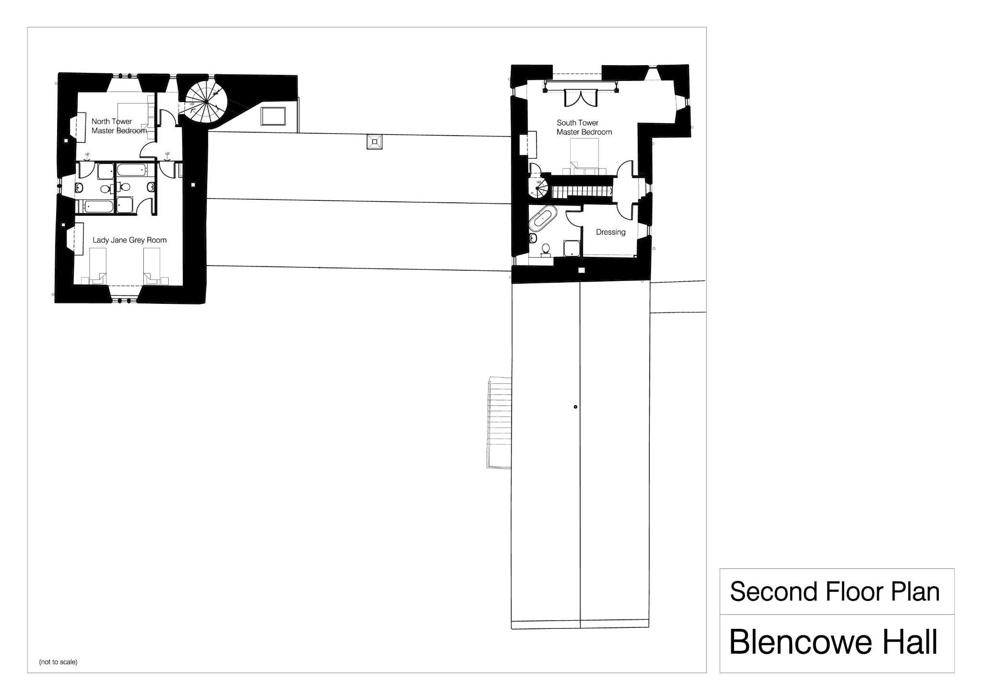
Second Floor

Blencowe Hall – Fire Assembly Point

Please review the following instructions and plan carefully upon arrival and ensure that all members of your party are aware of these. In addition to being provided to guests on arrival, these instructions are placed in the Rowley Estates Guest Information folder and mounted in the passage joining the kitchen and the Butlers Pantry, in the first floor Solar (main reception room). More detailed fire protection plans are also available in the Guest Information Folder.

Blencowe Hall is equipped with a smoke detector and fire alarm system and has emergency escape lighting along the main escape routes. The fire alarm gives a minimum sound output of 85 dB(A) at 3 meters. Lighted green fire exit signs are placed above the main fire exit doors and shown on the plan. There is automatic emergency lighting outside each marked fire exit door.

The escape routes, fire doors and assembly point are shown on the drawing which accompanies this plan.

If there is a fire which cannot be put out using the fire safety equipment provided (fire blankets and extinguishers are marked on the plan), please do the following:

- Leave Blencowe Hall immediately via the nearest fire exit door. The fire exit doors are marked with lit fire exit door signs. Do not re-enter the property after the fire alarm has sounded.

- Assemble at the Fire Assembly Point which is at the wooden bench in the main car parking area. Ensure that all members of your party have assembled at the Fire Assembly Point.

- Telephone the Emergency Services Department on 999 from this Fire Assembly Point using a mobile phone (there is normally signal at this location). If there is not a mobile phone available, see if the residents in Blaine Cottage or any of the guests in the other cottages are available to make this call using their land line telephones.

- Telephone Christine and Charles Rowley (the designated Responsible Persons) on either 07968 258 234, 07861 221 878, 07717 861 451, 0207 431 1453 or 0207 929 8861.

If a smoke alarm sounds and the cause of the alarm is not obvious, turn the key on the main alarm panel on the central staircaseill s all Press Silence/Resound Alarms, this will silence the alarms for a while and the location of the fire/fault will be shown on the alarm display panel.
staircase, to 1.

Locate the alarm(s) shown on the display panel. Be careful, check doors are not warm and there is no sign of smoke before opening any door. If you are fully satisfied that there is no fire press the Reset button on the panel and turn the key back to zero. (if the alarms have resounded you will need to repeat the silence procedure before resetting). The display panel will show ‘Panel in Reset’.

In the event of there being a fault in the alarm system the panel itself will buzz. Turn the key to 1, press Silence Buzzer then return key to zero position. The fault location will be displayed in the display panel.

Please telephone Christine or Charles Rowley in the event of any questions regarding the hush/reset feature or any other aspects of this Fire Evacuation plan.

